**Navpravartak**

**Providing Geo-Fencing Box (GFB) for Regulation of Geo-Fencing in Drones**

**Team Leader :** Abhinav Rai

**Team Members**

|  |  |  |  |
| --- | --- | --- | --- |
| **Name** | **Gender** | **Email** | **Phone** |
| Abhinav Rai | Male | abhinavrai44@gmail.com | 8130331755 |
| Sonaal Dua | Male | sonaal90@gmail.com | 9811422320 |
| Gaurav Sharma | Male | gauravsharma.gspt@gmail.com | 9873735228 |
| Adhyan Srivastava | Male | adhyan@outlook.in | 9560319498 |
| Saba Khan | Female | droptosabakhan@gmail.com | 9891561720 |
| Umer Ahsan | Male | 1201umer@gmail.com | 9958699410 |

**Problem Code -** #CA40

**Problem Statement Description**

Our problem statement was to develop a geo fencing system that would restrict the drones from entering the defined restricted areas, by warning the users every time their drone proceeds towards a restricted zone, implemented under the regulation of the government authorities.

Additionally, we extended our project to develop a product that would restrict the drones from entering by not only warning the user but also overriding the control mechanisms of the drone i.e whenever a drone enters a restricted area our override mechanisms will kick in and the control is taken from the user to tackle with such critical situations.

**Solution Proposed Description**

We have provided a working and practically implementable solution to this problem statement called **GFB ( Geo -Fencing Box)**. The GFB is a hardware cum software product which would be present and interfaced with each drone, under the regulation of the government. The presence of GFB would ensure the override mechanisms to be kicked in as soon as an illegal entry to the restricted zone is detected. The real-time presence/absence of the drone in any restricted zone is based on Dual-Security mechanisms of GFB:

* GPS based restriction
* RF beacon based restriction

**Summary**

The **Geo-Fencing Box (GFB)** will be installed and interfaced with the commercially available drones. The interface would consist of signal/action pins to be attached with the GFB so as to warn and notify the user, of any movement towards the restricted zones, and overriding the user control over the drone by activating an ‘override mode’ provided on the controller of the drone by the manufacturer, when the drone enters a restricted zone.

The GFB uses Dual-Security mechanisms based on 2 technologies, namely GPS and RF to achieve the defined objective. Each technology’s functionality is discussed below:-

**GPS**

The whole of Indian landmass is divided into 3 zones :-

* **Red** - No Flying Zone.
* **Yellow** - Notification Zone to alert the user of the close proximity of a restricted area (i.e. Red Zone). This zone behaves as a margin for the enclosed red zone.
* **Green** - Safe Flying Zone.

The creation of these zones is done using a simplistic user interface (Zone Selector) developed wherein the authorities can select and define any region into any of the 2 categories (red or yellow) simply with the drag of a mouse. All other areas are considered as green zones.

A snapshot of the zone selector interface is shown below.

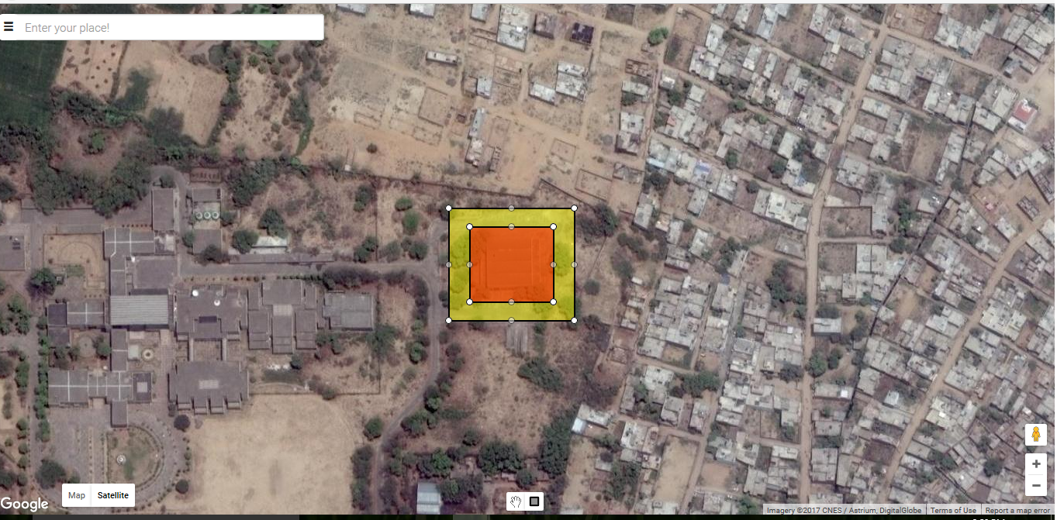

These zone will be stored in the onboard memory using SD card. On real time basis the corresponding position coordinates from the GPS module will be checked and compared against the zones stored onboard and kick in override mechanism when required.

**RF**

While the GPS technique is good for creating a static fence, what if the restricted zone is also in motion. This type of situation may arise when a highly designated authority such as the President or the Prime Minister’s convoy is on the move.

To tackle this problem we make use of the RF technology. The RF beacon will be placed on the intended infrastructure/object around which restricted zone is to be created. This beacon broadcasts a danger signal in the defined range as per the requirements.

If any drone enters these RF zones, the drone would automatically start sending the whereabouts of its location and drone id which would be made visible to authorities at place.

For this, a simple interface (Beacon Interface) is developed ,which shows the position of all flying drones in the RF range on Map and also the controls ( In-Air holding/landing) of the specific drones are also present.The beacon interface is shown below:

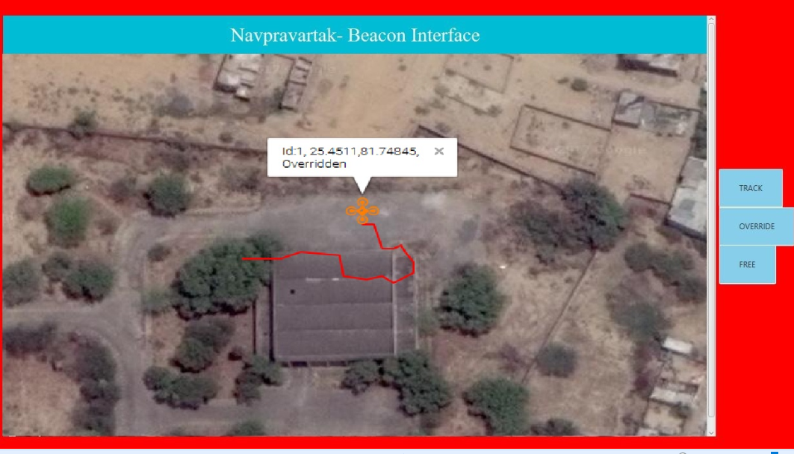

**Why GFB is feasible**

GFB satisfies 3 important factors which makes it feasible to implement as an extension to existing drones:-

1. Cost - The extension in itself must not exceed an appreciable percentage of the total manufacturing cost. Our solution was developed under Rs.1000 under the prototype phase. This cost can be further brought down if GFB is mass-produced.
2. Scalability - GFB being a hardware device is **compatible with all the drones** as this is independent of the drone mechanism/algorithm used for its flight, but is based upon the basic provision from a flight controller to override its normal flight functioning when an intrusion occurs, to issue alert or initiate safety measures.
3. Implementable - Our solution involves integrating the GFB with the flight controller available on the drone. This integration in itself is minimalistic and involves making hardly a couple of connections to the flight controller. Thus the external interfacing is very low and GFB can be easily integrated with any of the existing drones without bringing any major changes to the existing design.

**Technology stack**

1. Programming Environment - Embedded C (AVR Studio / Arduino IDE)
2. Microcontroller - Atmega328/Atmega2560 (Arduino Development Board)
3. GPS Module(Neo 6M)
4. RF Transceiver Module (Nrf2401L+ / LoRa )
5. Storage - SD card (FAT File System)
6. Extreme Burner Software
7. Java (for application development)
8. Google Maps API

**Further Development**

We have identified a set of improvements which must be introduced into GFB :-

* There is a need for the regular updation of static data present in the SD card which is mounted on GFB box. So we will provide an easy to use software which the user can download from the official site and it will update the data present on the SD card.
* In case the user does not upgrade the onboard data in the SD card, then a provision to prevent the drone from functioning needs to be implemented.
* Configuration of the Rf beacons range will be decided by the infrastructure of the restricted areas.
* Use of encryption techniques for messages transmitted over the RF.
* Improve the beacon interface to show the plotting of multiple drones flying concurrently in a restricted area.
* Optimize the size of the hardware as per the requirements.
* Provision for safety mechanisms in case of tampering with the GFB.

We are always open to the suggestions from mentors at the ministry to further improve our

Project.